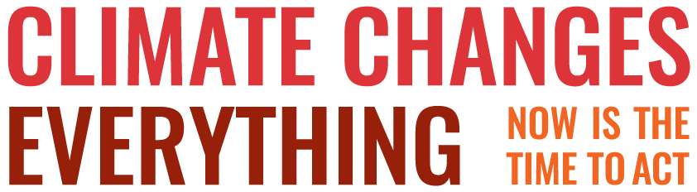

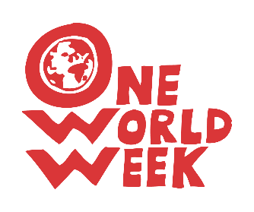

Islamic Foundation for Ecology and Environmental Sciences (IFEES)
is a UK registered charity operating internationally, through programmes designed to increase knowledge and awareness, alleviate poverty, combat climate change and deal with other major environmental issues.

On its website www.ifees.org.uk/ you will find the following resources to download:

- Islamic Declaration on Climate Change
- Launch of the Islamic Declaration on Climate Change (on YouTube) - Muslims from various organisations, including IFEES and Islamic Relief Worldwide, explain why it is so important and people of various Faiths welcome it.

- Muslim Green Guide to Reducing Climate Change
You could:
- share them with local Muslim communities,
- organise a discussion,
- use them at an inter faith event
- tell non – Muslims about them.

In this climate emergency, which threatens to end life as we know it on our planet, we all need to work together.

“But that He (God) may try you in that which He has given you:
So vie with one another in doing good deeds”
Qur’an 5: 48

